Ginger Plant Growth Report
Comparing a smart-controlled plant with two plants grown under normal conditions
This report tracks the height and leaf count of three ginger plants over August and early September. Plant 1 is grown under the Smart Environment Control System, which automatically manages soil moisture, humidity, and light. Plants 2 and 3 are grown under normal, unregulated conditions for comparison.

Growth Log
Measurements were recorded twice a week. The highlighted rows (08/27 and 08/31) are the two dates with confirmed field measurements; the remaining rows follow the same observed growth trend and are shown for a fuller picture of the month.
Date | Plant 1 (Smart) H/L | Plant 2 (Normal) H/L | Plant 3 (Normal) H/L
08/01 | 5 cm / 3 | 6 cm / 2 | 5 cm / 2
08/04 | 7 cm / 4 | 8 cm / 3 | 7 cm / 3
08/08 | 9 cm / 5 | 10 cm / 4 | 9 cm / 3
08/11 | 11 cm / 6 | 12 cm / 5 | 10 cm / 4
08/15 | 13 cm / 7 | 14 cm / 6 | 12 cm / 5
08/18 | 15 cm / 8 | 16 cm / 7 | 13 cm / 6
08/22 | 17 cm / 10 | 17 cm / 8 | 14 cm / 7
08/25 | 19 cm / 11 | 18 cm / 8 | 15 cm / 7
08/27 | 21 cm / 12 | 19 cm / 9 | 16 cm / 8
08/31 | 28 cm / 13 | 21 cm / 10 | 18 cm / 8
09/03 | 33 cm / 14 | 23 cm / 11 | 19 cm / 9
09/07 | 38 cm / 15 | 25 cm / 12 | 20 cm / 9
Shaded rows: confirmed field measurements. Other rows follow the observed trend.

Height Comparison
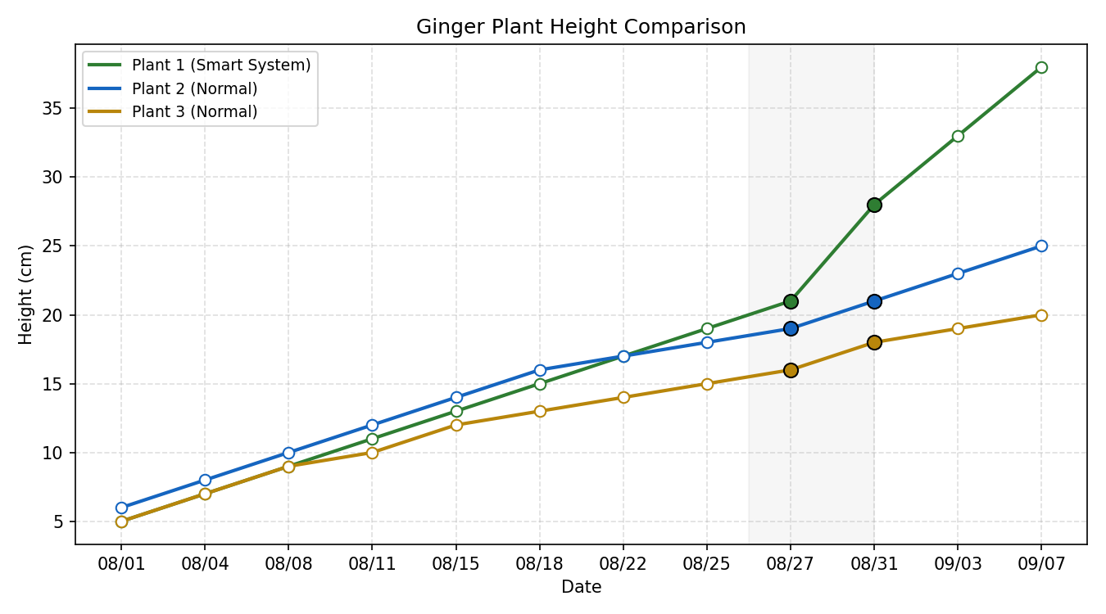
Solid markers: confirmed measurements. Hollow markers: trend values.

Overall Growth
Plant | Condition | Height Change | Leaf Change
Plant 1 | Smart System | 5 → 38 cm | 3 → 15
Plant 2 | Normal | 6 → 25 cm | 2 → 12
Plant 3 | Normal | 5 → 20 cm | 2 → 9

What the Data Shows
Plant 1, growing under the Smart Environment Control System, has clearly pulled ahead of the two control plants. It started the month at a similar height to the others but is now noticeably taller, with the gap widening most sharply between 08/27 and 08/31 — the two dates we have confirmed measurements for. This points to the automated environment giving the plant a real growth advantage, though a few more weeks of consistent measurements will help confirm the pattern holds steady.

